Photress

Version <1.1>

Revision History

|  |  |  |  |
| --- | --- | --- | --- |
| **Date** | **Version** | **Description** | **Author** |
| 24.10.2013 | <1.0> | First version of Organize photos in albums | Benny Görzig |
| 31.10.2013 | <1.1> | Added Postconditions for “Organize” Added Mockup Added Narration and 2 Scenarios | Benny Görzig |
|  |  |  |  |
|  |  |  |  |

Table of Contents

1. Organize photos in albums 4

1.1 Brief Description 4

2. Flow of Events 4

3. Special Requirements 4

4. Preconditions 4

5. Postconditions 4

6. Extension Points 5

7. Mockup 5

8. Narration 6

# Organize photos in albums

## Brief Description

The Use Case “Organize photos in albums” is accessible for the actors “admin of own gallery” and “admin of hosted gallery”. The actor will be able to organize his photos in albums. Additionally, he will be able create, view, update and delete his albums (CRUD). Additionally, he can put his photos into albums to organize them.

# Flow of Events

You will find the latest version of the activity diagram under the following link:

<http://photress.it.dh-karlsruhe.de/?p=46>

# Special Requirements

N.a.

# Preconditions

Create: The actor has an activated account.

Read/Update/Delete: The actor has to have an activated account and albums connected to this account.

Organize the photos: The actor has to have an activated account; albums connected to this account

and uploaded photos to organize.

# Postconditions

Create: The actor has a new album connected to his account.

Read: The actor has a list view of his albums.

Update: The actor has an updated version of his album.

Delete: The selected album is deleted.

Organize the photos: The image/s is/are in the new specified location.

# Extension Points

N.a.

# Mockup

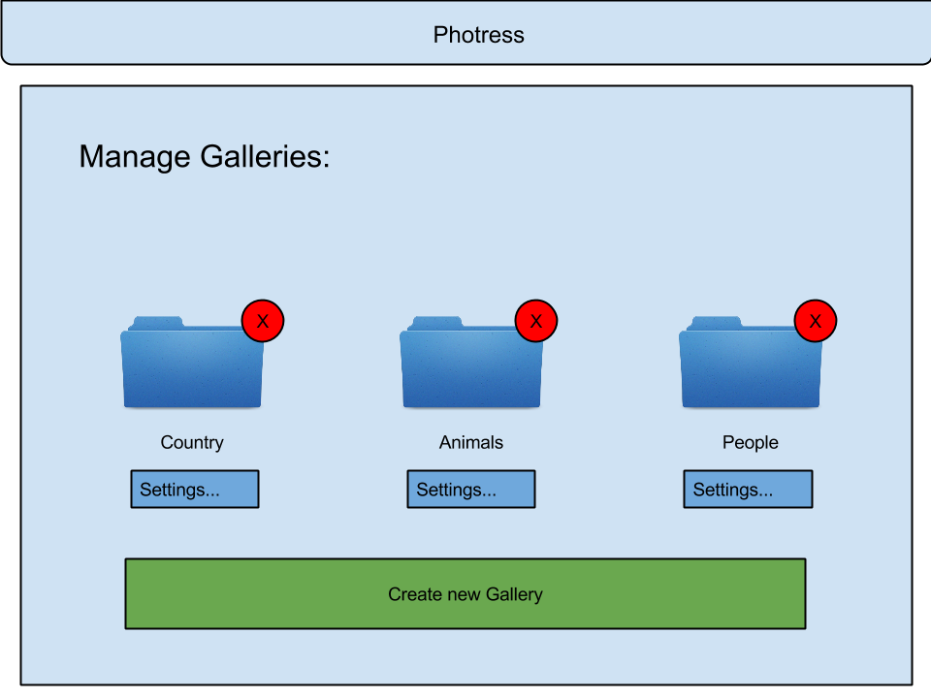

# Narration

Feature:

As a Admin of hosted gallery

I want to organize photos in albums

so that I can manage my photos in albums.

Scenario: create album

Given I am logged in

And I am on the managing page

When I click on "create new album"

And I enter a valid name

And click "Okay"

Then I should see "successfully created a new album"

And I should have a new album

Scenario: put photo into album

Given I am logged in

And I am on the managing page

When I drag "photo.png" from the list

And drop it on the album "new album"

And open "new album"

Then I should see "photo.png"

Scenario: delete album

Given I am logged in

And I am on the managing page

And I have selected "new album"

When and I click on "delete"

And I click on "okay"

Then I should see "deleted album 'new album'"

And I should'nt see "new album"